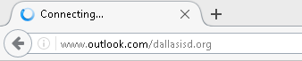 | Sign in to your email on any browser on your computer.
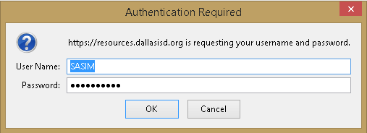 | Enter your username and password.
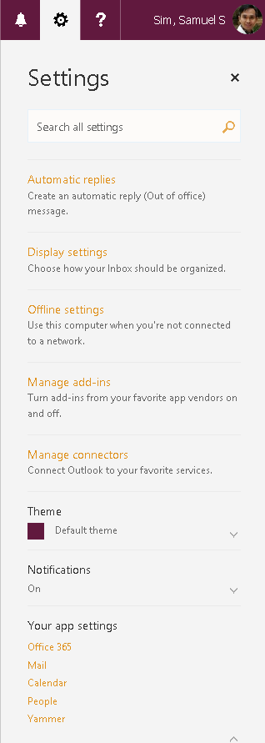 | At the top right of your email you’ll see a Settings symbol. Click on it and go down to Your app settings:  Click > on Office 365  It will take you to the next page.
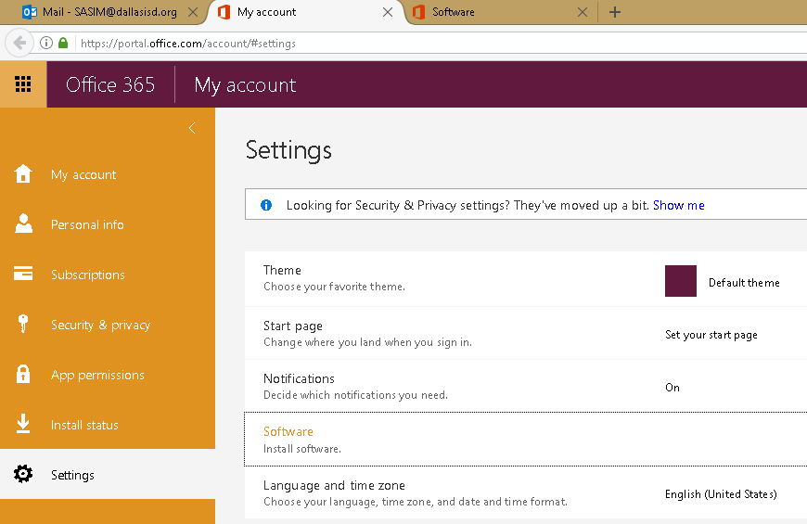 |  | Click> Software to Install software.
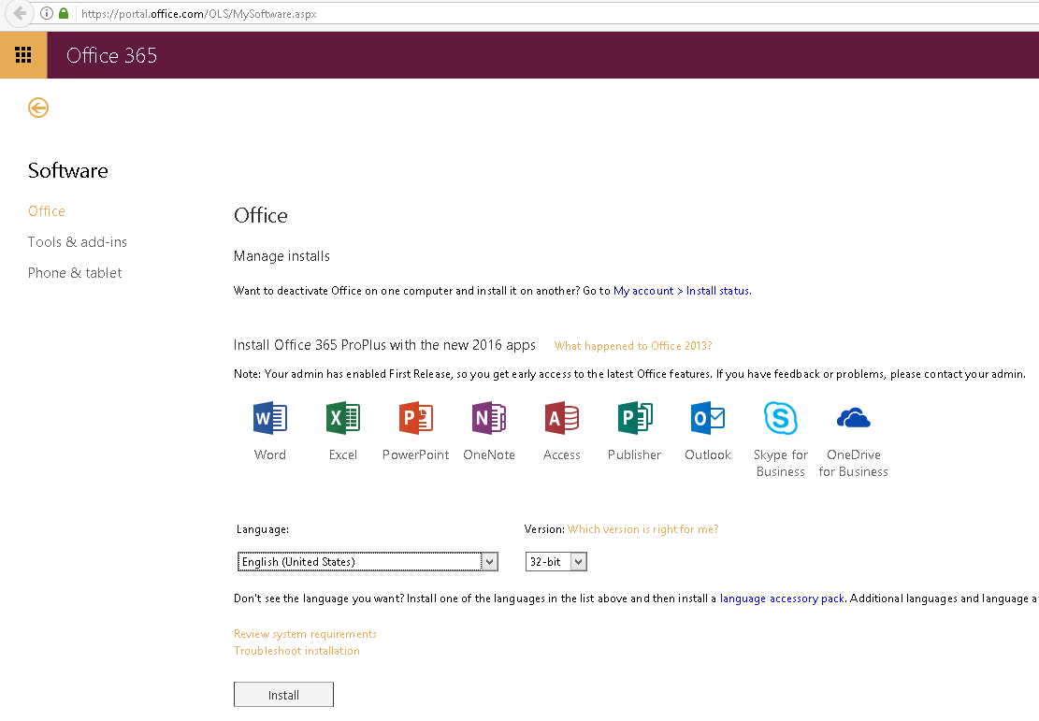 |  | Click  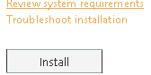  Install at the bottom.
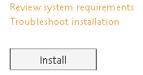 | Once completed restart your computer.

