How to set up DISD email account to an Exchange account on your iPhone, iPad.
- Open the Settings app.
- Tap Mail, Contacts, Calendars
- Tap Add Account.
- Tap Microsoft Exchange.
- Enter your Exchange ActiveSync account settings (see your IT administrator or service provider if you don’t know them). NOTED: I have them below…
- 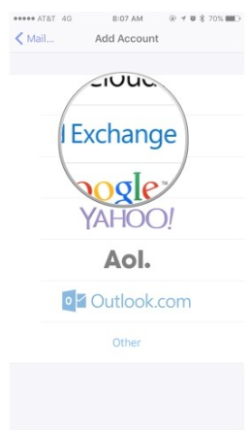
- Enter Information as shown below but use your DISD email address and password.
- 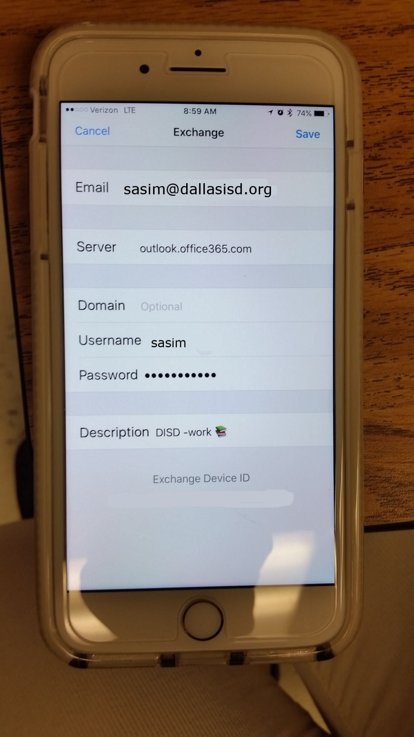
- Tap Save
- If you still unable to connect to the email: make sure connect to DISD WIFI with you username and password then try connecting again. If you still having issue please put in incident ticket. Thank you!
For Android Phone Setting: